Oppose Private School Vouchers For Military-Connected Students | 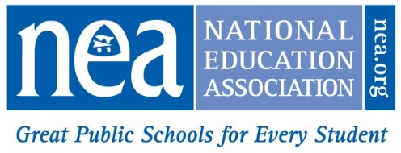
……………………………………………………….…………….
The Military Education Savings Accounts Act (S. 2517/H.R. 5199) creates a federally funded voucher program for students with parents on active military duty. Over the next few weeks, we expect efforts to attach this bill to the must-pass National Defense Authorization Act (NDAA).

WHAT’S IN A NAME?
- Whether they’re called vouchers, education savings accounts, or tuition tax credits, the impact is the same: robbing public schools of funding and resources that may already fall far short of what is needed.
- Vouchers divert funding and resources from public schools to private, often religious, schools ill-equipped to provide the same comprehensive services and support as public schools — especially important for students from military families who must deal with issues such as frequent moves and having a parent deployed overseas.

PROPOSED PROGRAM
- Funding for vouchers for military-connected students could come from federal Impact Aid for public schools serving large numbers of military-connected students.
- Ten million students would be affected if Impact Aid is diverted to vouchers as the Military Education Savings Account Act envisions, according to the National Association of Federally Impacted Schools.
- A voucher program is a bad idea even if Impact Aid is spared.
- The National Military Family Association and the Military Officers Association of America (MOAA) oppose vouchers because they hurt the very students proponents claim to help.

PUBLIC VS. PRIVATE SCHOOLS
- The overwhelming majority of America’s students — 9 out of 10 — attend public schools.
- Private schools can deprive students of religious freedom, civil rights and protections, fail to provide adequate support for those with disabilities, and are not accountable to the public.
- Taxpayer dollars should go to public schools open to all students, not private schools that can pick and choose their students based on economic status, academic achievement, or even gender.
- America cannot afford to fund two education systems — one private and one public — on the taxpayer’s dime.

