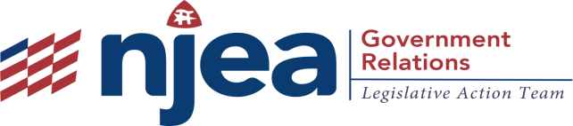
Budget Summary

- Total Budget: $37.4 Billion

- Total Education Budget including pension payment: $14.9 billion
  - $8.6 billion would be direct aid to schools (increase is about 3.5 percent increase over the current year)
  - No district will lose aid; 94% of districts will get an increase in state aid
  - Goal: to fully fund K-12 schools over the next four years
  - Funding for pre-K-12 would increase by $341 million overall
  - $283.6 million for K-12 and $57.6 million for pre-K expansion (for more than 3,500).
  - $3.2 billion pension payment
  - A 28% increase over last year’s contribution.
  - Larger than the total of all contributions made during the Christie Administration’s first term.
  - The proposal includes $3.4 billion for active employee health benefits and post-retirement medical health benefits

- Higher Education
  - $2.4 billion in direct support for higher education and student financial aid programs
  - $50 million in new aid for community college tuition assistance for the new fiscal year.
  - Goal: to offer tuition-free community college to all by 2021.
  - This budget will fund tuition free community college for 15,000 additional students whose family incomes fall below $45,000 starting in spring 2019.
  - Funding for Tuition Aid Grants would increase $7 million; Educational Opportunity Fund by $1.5 million

- Revenue Raisers
  - Total revenue it would raise: $1.7 billion
  - Millionaires Tax: The proposed budget would increase taxes on New Jersey households earning more than $1 million a year from 8.97 percent to 10.75 percent. This change, estimated to bring in $765 million, would be retroactive to January 1, 2018.
  - Marijuana: $80 million in sales tax revenue from marijuana, including $20 million from expanding the existing medical marijuana program and $60 million from legalizing recreational marijuana.
  - Sales Tax: The proposal would raise the state sales tax from 6.625 percent to 7 percent, and expand it to include some new items like the ridesharing service Uber. This is expected to generate about $581 million. With this hike in the sales tax, Murphy is restoring the cut made by Gov. Chris Christie as part of a deal to replenish the state's Transportation Trust Fund.
  - Closing Tax Loophole: The proposal would close the "carried interest loophole," that allows wealthy money managers to characterize some of their earnings as lower-taxed capital gains, rather than ordinary income. This is projected to raise $100 million in revenue.
  - Changes to Corporate Business Tax Code: Making technical changes to the corporate business tax code to generate $110 million.

- OTHER INTERESTING STUFF
  - The Governor proposed a $2 million grant program to help high schools offer college-level Computer Science courses and to support teachers’ professional development.
  - Raising the Minimum Wage. This budget plans for a statewide increase to a $15 minimum wage, including an increase to $11 per hour in fiscal 2019.
  - Raising the Property Tax Cap: Governor Murphy supports bipartisan legislation to raise the deduction from state income taxes to $15,000.
  - Confronting Gun Violence: New Jersey will establish the Center on Gun.
  - Violence Research: The Governor’s budget also recommends raising firearm fees, many of which have not been updated since the 1960s.

