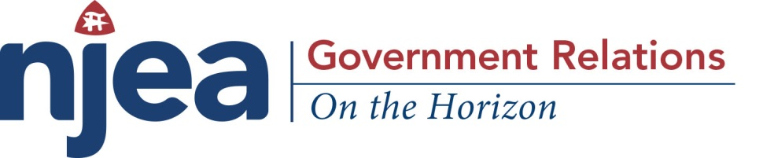
March 2, 2018
JANUS V. AFSCME
Mark Janus is a child-support specialist for the Illinois Department of Healthcare and Family Services.

He is an agency fee payer (a required fee that covers the costs of the union’s collective bargaining activities) because he does not want to belong to the American Federation of State, County and Municipal Employees (AFSCME) - the union that bargains the contract for Janus and his fellow public employees.

Janus is suing AFSCME because, as he puts it, “the union’s fight is not my fight.”

- Janus v. AFSCME challengers are directly asking the court to overturn a 1977 U.S. Supreme Court decision Abood v. Detroit Board of Education. That ruling legislated states could allow public-employee unions to collect fees from nonmembers to cover the costs of workplace negotiations but not the union’s political activities.
- Janus believes agency fees in the public sector violate his first amendment free speech rights by forcing him to support political activity with which he disagrees
Impact of Janus Decision:
The Janus v. AFSCME case will impact over 5,000,000 public employees by automatically making all states ‘right-to-work’ states.

Right-to-work is a term coined by big corporations to make it appear that being a part of a union infringes upon our personal rights, but what it really does is:

- eliminate the collection of agency fees (currently legal in 22 states) for those employees who do not want to support a union and;
- create a culture of ‘free riders’ – employees who receive all the benefits of a union contract and union representation without paying a dollar to the union for its efforts; and,
- weaken union members’ ability to negotiate with employers, enforce contracts, and protect worker rights, benefits, pay and pensions.

…over, please

The goal of right-to-work supporter’s is to bust unions: they falsely claim that it protects workers who don’t want to join a union or disagree with a union’s politics.

Corporate interests like multi-national corporations, the National Right to Work Committee and the U.S. Chamber of Commerce, are spending millions of dollars running campaigns to get members to quit their union , but…

In reality, right-to-work laws take away workers’ rights, and federal labor law already protects those who don’t want to join a union or support political advocacy.

###

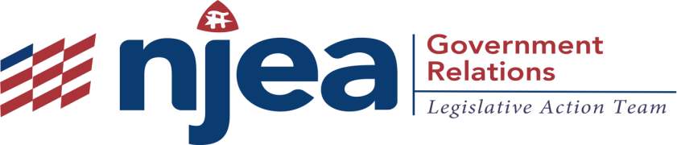

BY Kim Kohlhaas
NEW YORK DAILY NEWS
Monday, February 26, 2018, 5:00 AM

Rallying against reform in 2011
(DARREN HAUCK/REUTERS)

My third-grade class in Superior, Wis., went from 15 students to 32 — and on some days more than 60 when a colleague was out sick.

Funding for public schools and programs fell. Schools became revolving doors as teachers fled to different districts or different professions.

All because of Wisconsin’s Act 10, a 2011 law pushed by Gov. Scott Walker that gutted collective bargaining rights for public employees, including teachers.
I am sharing this cautionary tale because today, the U.S. Supreme Court will hear an anti-union case that could wreak similar havoc across the nation.

The impact on Wisconsin was extraordinary. In a short time, I had taken a $10,000 cut in take-home pay and benefits. But in a larger sense, my profession had changed irrevocably.

A colleague who stood up to her principal on behalf of a student — in the presence of the child’s parent — was terminated shortly after the incident. Act 10, which made her an “at will” employee, had effectively removed her opportunity for due process and her ability to advocate on behalf of students.

Professional standards have also taken a hit. To deal with the teacher shortage created by the passage of Act 10, state lawmakers passed legislation this year that allows someone to earn a teaching license with 15 months of online coursework. On Black Friday, these courses were on sale.

And the enemies of public education have grasped the opportunity. Despite the fact that a recent independent study found that on the whole voucher students in Milwaukee scored no better than public school students on standardized tests, the local voucher program was expanded statewide, and per-student funding is now higher for voucher students than for public school children.

…over, please

Act 10, which sharply limited collective bargaining rights for public-sector workers, had been sold to voters and the legislature as a way to reduce taxes. Families that I knew got tax reductions of $13 even as the quality of their schools — and other public services — took a nosedive.

And while the backers of the federal Janus vs. AFSCME case, which could result in prohibiting public unions from collecting agency fees from employees, maintain publicly that it’s just about free speech rights, their real agenda — like Walker’s — is to undermine unions and the voice of ordinary working people.

My concern is that members who pay their dues for contract bargaining and employee benefits will end up paying not only for themselves but for those who do not. Union resources will continue be spread thin, leaving unions less able to advocate on behalf of students and teachers.

The Janus case is named for an individual plaintiff, Mark Janus. But the real powers behind the lawsuit are right-wing interest groups like the National Right to Work Legal Defense Foundation that seek to weaken unions, their members and their families.

Groups like this are threatened by the fact that unions give workers the ability to come together to protect their interests and the interests of working people everywhere, to insist on a livable wage and financial security.

The Wisconsin teachers union is rebuilding from the effects of Act 10, one local at a time. We are running pro-education, progressive community members and parents for local school boards — and winning. We are training our own members to run for City Councils and local county boards. Long term, we want to field state-wide candidates and work to undo much of the damage.

Our success can be a model, even if the Supreme Court decides against us. Unions will survive. They mean too much to their members, our members and to our society to simply surrender to the forces that would divide us. We have the tools we need to weather this and any other court decision because we have each other.

But for the sake of our society and our families, I hope the Supreme Court turns back the Janus case, and that schools, teachers and other workers across the country do not have to go through what we have had to endure.

Kohlhaas is the president of the American Federation of Teachers-Wisconsin.

###

