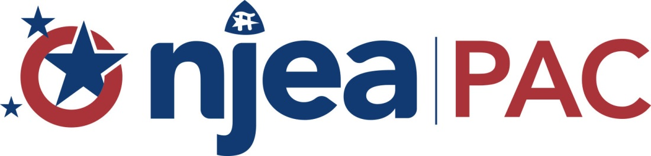
The Non-Partisan Voluntary Voice of New Jersey Education Association Members
180 WEST STATE STREET • POST OFFICE BOX 1211 • TRENTON, NJ 08607-1211 • 609-599-4561 • FAX: 609-394-3355

PUBLIC QUESTION

New Jersey Revenue from Environmental Damage Lawsuits Dedicated to Environmental Projects (approved for November 2017)
SCR-39 (2016-2017)
Passed Senate (28-8), Assembly (56-18-3), 12-19-16.

Amends Constitution to dedicate all State moneys received from settlements and awards in cases of environmental contamination for certain environmental purposes

OFFICERS’ RECOMMENDATION: NO POSITION

RATIONALE:

This amendment would constitutionally dedicate all moneys from settlements and awards collected by the State in connection with legal claims based on environmental contamination to natural resource damages. The dedicated amounts may be used to repair, restore, or replace damaged or lost natural resources of the State, or permanently protect the natural resources of the State, or pay the legal or other costs incurred by the State to pursue the awards relating to natural resource damages. NJEA took no position on the bill in the Legislature.

Due to the fluctuating nature of such awards, the Office of Legislative Services (OLS) was unable to estimate the amount of such revenue. However, OLS noted that budgetary appropriation language in recent years has dedicated the first $50 million of such awards to these cleanup projects—with any excess deposited into the general fund.

The amendment hamstrings the state from using any windfalls from litigation or settlement for other obligations, such as pension funding. As an example, the Department of Environmental Protection represented that may receive $226 million to $236 million in damage awards in Fiscal Year 2017—a significant amount. Under the amendment, this would only go to redress environmental damage and costs.

The amendment would, in theory, free up nominal budgetary resources for other purposes. The amendment allows up to 10 percent of such awards to go to state agencies tasked with enforcing these rules. This would offset some state funding typically allocated for this purpose and could free up resources for pensions and school funding.

In a time of pressing state obligations on pensions and school funding, NJEA cannot endorse restricted flexibility on all state resources for long-neglected financial commitments. Nevertheless, NJEA members value the vital role of our natural resources with educating, informing, and inspiring our students. Polluters should be answerable for their environmental damage and should correct their harm. It would therefore be inappropriate to oppose the dedication of these rightful awards for these purposes and NJEA will take no position on the amendment.

…over, please

 |  | CONSTITUTIONAL AMENDMENT DEDICATING MONEYS FROM STATE ENVIRONMENTAL CONTAMINATION CASES
 | YES | Do you approve amending the Constitution to dedicate all moneys collected by the State relating to natural resource damages in cases of contamination of the environment? The moneys would have to be used to repair, restore, replace, or preserve the State’s natural resources. The moneys may also be used to pay legal or other costs incurred by the State in pursuing its claims.
 |  | INTERPRETIVE STATEMENT
 | NO | This amendment would dedicate moneys collected by the State relating to natural resource damages through settlements or awards for legal claims based on environmental contamination. These moneys would be dedicated to repair, replace, or restore damaged natural resources, or to preserve the State’s natural resources. The moneys would be spent in an area as close as possible to the geographical area in which the damage occurred. The moneys could also include cleaning contaminated sites and underground storage tank sites, funding water quality programs, or preserving open space, farmland, or historic buildings or sites be used to pay for the State’s legal or other costs in pursuing the claims. Currently, these moneys may be used for any State purpose.

