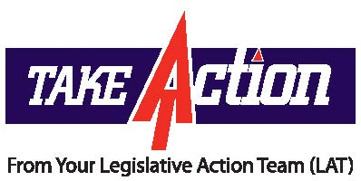

**KEEP THE CALLS COMING!**

**Resolution to Eliminate PARCC as High School Graduation Requirement on the Move!**

On Thursday, March 16, 2017, the voices of thousands of NJEA members were heard loud and clear as the General Assembly voted 67-3-2 to pass ACR-215. (*This resolution aims to end the use of PARCC as a graduation requirement*.) NJEA members made countless phone calls and sent nearly 1,000 email messages to their representatives.

SCR-132 (Gill, Turner, Codey) and ACR-215 (Jasey, Caride, Benson, Quijano, Caputo, Jimenez, Jones, McKeon) are concurrent resolutions that stipulate that the State Board of Education’s regulations adopted last August and require students take and pass PARCC are not consistent with current legislation that determines standards for high school graduation.

The resolution also directs the State Board of Education to amend or withdraw the regulations within 30 days, or the Legislature may pass another concurrent resolution to invalidate the regulations. The resolution *does not* require Gov. Christie’s signature.

SCR-132 still has not been heard in the Senate Education Committee.

**TAKE ACTION**

**First:** Contact your member of the Senate and ask them to co-sponsor SCR-132.

**Second:** Call Senate President Steve Sweeney and remind him as Senate President that he has the responsibilityto make sure the bill is heard in committee.  The Senate is his house and he needs to ensure that the voices of thousands of parents and educators who believe PARCC is a flawed test, and should not be used as a graduation requirement, are heard.

**Talking Points:**

* The State Board of Education regulations requiring students to demonstrate proficiency on PARCC ELA 10 and Algebra I are inconsistent with the intention of the P.L.1979 law that established a program of standards for graduation from high school, including a statewide assessment test in reading, writing and computational skills.
* State law regarding high school graduation standards refer to a single, comprehensive graduation assessment given in the 11th grade. The PARCC tests, as authorized under the new regulations are two separate tests, PARCC ELA 10 and Algebra I, given at the end of the relevant course.
* For the classes of 2016 – 2020: If a student does not demonstrate proficiency on the ELA 10 or Algebra I assessments, the regulations offer no option for retesting using these exams. Instead, students may use an alternative third-party assessment, such as the SAT, PSAT, ACT other PARCC assessments or a portfolio appeal.
* Starting with the class of 2020, students may use an alternative assessment to show proficiency ***only after*** they have taken all applicable high school end-of-course PARCC assessments for courses in which they are enrolled.

*March 17, 2017*